Lab 5 – Building a Small Network

1. Topology

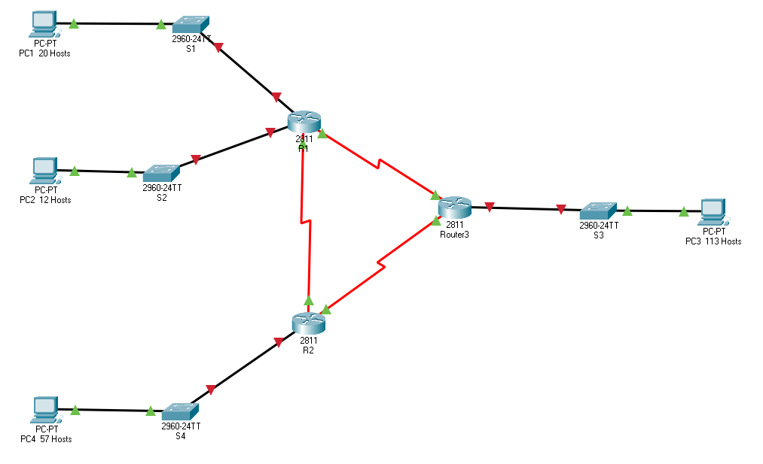

1. Addressing Table

|  |  |  |  |  |  |
| --- | --- | --- | --- | --- | --- |
| Device | Interface | Network Address | IP Address | Subnet Mask | Default Gateway |
| R1 | FA0/0 | 100.50.20.192 | 100.50.20.193 | 255.255.255.224 | N/A |
| FA0/1 | 100.50.20.224 | 100.50.20.225 | 255.255.255.240 | N/A |
| S0/0/0 | 100.50.20.244 | 100.50.20.245 | 255.255.255.252 | N/A |
| S0/0/1 | 100.50.20.240 | 100.50.20.241 | 255.255.255.252 | N/A |
| R2 | FA0/0 | N/A | N/A | N/A | N/A |
| FA0/1 | 100.50.20.128 | 100.50.20.129 | 255.255.255.192 | N/A |
| S0/0/0 | 100.50.20.248 | 100.50.20.249 | 255.255.255.252 | N/A |
| S0/0/1 | 100.50.20.244 | 100.50.20.246 | 255.255.255.252 | N/A |
| R3 | FA0/0 | 100.50.20.0 | 100.50.20.1 | 255.255.255.128 | N/A |
| FA0/1 | N/A | N/A | N/A | N/A |
| S0/0/0 | 100.50.20.240 | 100.50.20.242 | 255.255.255.252 | N/A |
| S0/0/1 | 100.50.20.248 | 100.50.20.250 | 255.255.255.252 | N/A |
| S1 | VLAN 1 | N/A | 10.50.20.194 | 255.255.255.224 | 100.50.20.193 |
| S2 | VLAN 1 | N/A | 10.50.20.226 | 255.255.255.240 | 100.50.20.225 |
| S3 | VLAN 1 | N/A | 100.50.20.2 | 255.255.255.128 | 100.50.20.1 |
| S4 | VLAN 1 | N/A | 100.50.20.130 | 255.255.255.192 | 100.50.20.129 |
| PC1 | NIC | N/A | 100.50.20.195 | 255.255.255.224 | 100.50.20.193 |
| PC2 | NIC | N/A | 100.50.20.227 | 255.255.255.240 | 100.50.20.225 |
| PC3 | NIC | N/A | 100.50.20.3 | 255.255.255.128 | 100.50.20.1 |
| PC4 | NIC | N/A | 100.50.20.131 | 255.255.255.192 | 100.50.20.129 |

1. Objectives

Part 1: Design an IP Addressing Scheme

Part 2: Assign IP Addresses to Network Devices and Verify Connectivity

1. Scenario

In this activity, you are given the network address of 100.50.20.0/24 to subnet and provide the IP addressing for the network shown in the topology. Each LAN in the network requires enough space for at least the number of hosts indicated. Use the VLSM techniques taught in class to make the most efficient use of the IP space.

The number of hosts under each of the computer icons represents the number of end user devices (computers, laptops, printers, IP telephones, scanners, IP cameras, door security systems, etc etc). It does not represent, nor include, any other IP space requirements that you – as the Network Engineer – need to take into account.

1. Design an IP Addressing Scheme (10 Points)
   1. Subnet the 100.50.20.0/24 network into the appropriate number of subnets.
      1. Use the VLSM methodology taught in class
      2. Fill out the IP Addressing table above
      3. Assign the 1st host address in the subnet to the Router Fast Ethernet Interface
      4. Assign the 2nd host address in the subnet to the Switch Management Interface
      5. Assign the 3rd host address in the subnet to the desktop computer, representing all of the end user devices in that subnet.
      6. For the serial link, assign the host addresses for that subnet as you desire
2. Assign IP Addresses to Network Devices and Verify Connectivity (10 Points)

The routers are pre-configured with a routing protocol (EIGRP). Do not erase the router eigrp configuration

* 1. Configure IP addressing on all of the router, switch, and host device interfaces.

If your configurations are correct, you should be able to ping from any device in the network to any other device in the network. Full connectivity.

1. Configure all other basic router and switch configurations (5 Points)
   1. Configure basic configuration on the devices – as per the material that you have learned previously.
   2. Configure security on the devices – as per the material that you have learned previously.
   3. There are two methods of configuring a networking device (locally and remotely). Ensure that both methods are properly secured

Please include below the information that I will require to log in to your devices, once you have configured security and protected them.

Switch and router passwords: console password : 452IST

Privileged mode password: IST452